|  |
| --- |
| Rutgers university |
| Problem Set 2 |
| Econ 510 |
|  |
| **Arinze Nwoye** |
| **9/24/2015** |

|  |
| --- |
|  |

The dataset contains quarterly data of US GDP from 1959 Q1 to 2015 Q2. There are 226 observations. The variables included are the Nominal GDP, the M2 money supply, consumer price index and the 3-month Treasury bill rate. A number of steps were taken to make the series stationary. The Nominal GDP was deflated (to obtain real GDP) and then log differenced, the M2 money supply was deflated and log differenced, the inflation was obtained as the log difference of CPI and finally the ex-post real interest rate was obtained using the fisher equation and made stationary with a simple difference.

Below is a graph of the four variables: real GDP,

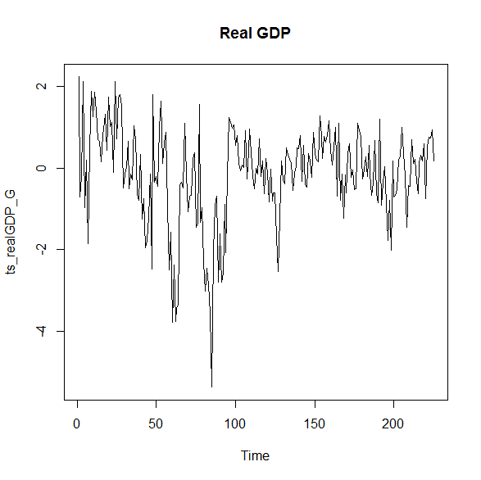

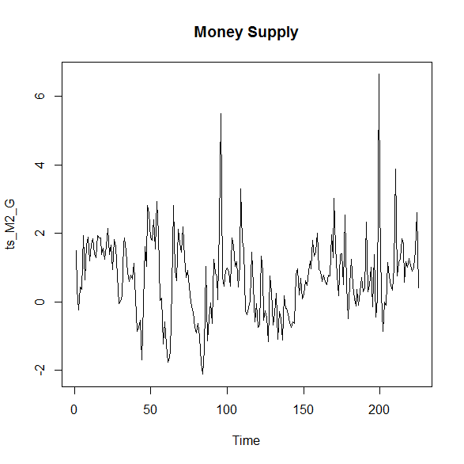

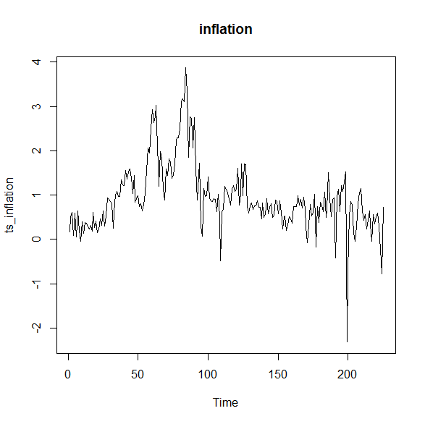

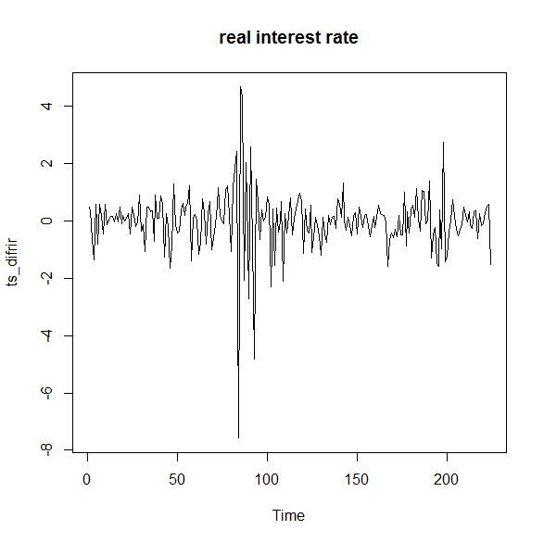

**Vector Autoregressions**

1a) In a bivariate model we take a granger causality test of money to output. The results are as follows:

Granger Causality H0: Money does not Granger-cause real GDP

F-Test = 2.0798

P-value = 0.01748

Based on the P-value we can reject the H0 at the 5% critical value and conclude that money granger causes output.

1b) Below is a 24-period impulse response function to output from a money shock.

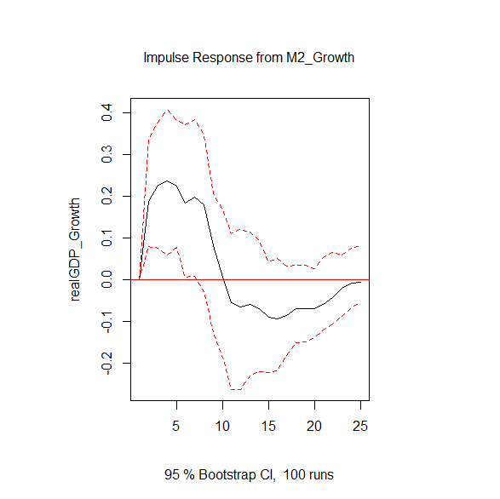

In the graph above, a 1% shock to money leads to an initial increase in output. The increase in output reaches its peak after 5 periods (or 5 quarters, just over a year) at 0.225%. After which there is steady decline that leads to decrease in output after 10 periods. However, the output seems to converge back to its pre-shock levels at the end of 24 periods.

1c) The real interest rate in added to our initial bivariate model and exercises (a) and (b) are repeated.

We start with the granger causality test of money to output in our new model. The results are as follows:

Granger Causality H0: Money does not Granger-cause real GDP and real interest rate

F-test = 1.4153

P-value = 0.09204

Based on the P-value we do not reject the null at the 5% critical value. Therefore, money does not granger-cause real GDP and the real interest rate. The result is differs from the granger causality test in exercise 1a because we did not account for the omitted variable (real interest rate) in the model. Therefore, it would seem that money does not have a direct causal effect on output only through the interest rate.

Below is an impulse response function of output to a shock in money in the new trivariate model:

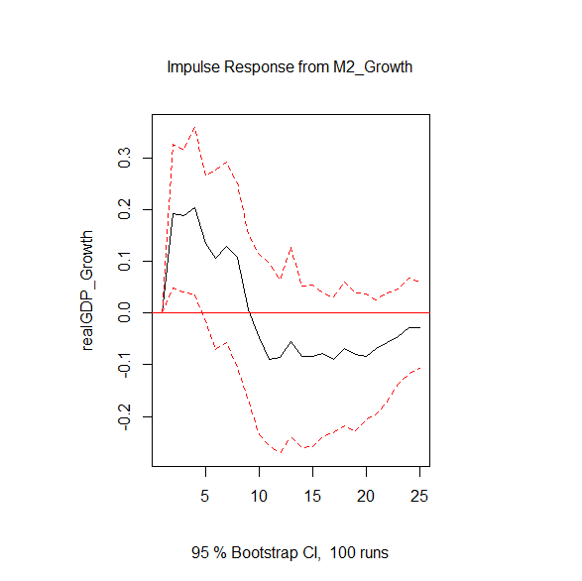

The graph shows the response of output to a 1% shock to money. The time path of the impulse response is similar to the bivariate model. The shock increases output initially and it reaches its peak after 4 periods (1 year) at 0.203% and steadily declines until it reduces output after 9 periods. The irf seems to be converging back to its pre-shock levels after 24 periods.

**Orthogonalization**

2a) In this exercise a four variable model is re-estimated in this particular order: real GDP, real interest rate, real money supply and inflation rate. Below is a table of the forecast error variance decomposition of real GDP.

|  |  |  |  |  |
| --- | --- | --- | --- | --- |
| **Real GDP Variance Decomposition** | | | | |
|  | **Real GDP** | **Real Interest Rate** | **Real Money Supply** | **Inflation** |
| 1 | 1.0000000 | 0.0000000 | 0.0000000 | 0.0000000 |
| 2 | 0.8140896 | 0.1275906 | 0.04826117 | 0.010058634 |
| 3 | 0.807852 | 0.1152432 | 0.06709427 | 0.009810466 |
| 4 | 0.7507039 | 0.1229884 | 0.09689346 | 0.029414271 |
| 5 | 0.7199609 | 0.1283408 | 0.09959847 | 0.052099904 |
| 6 | 0.6817838 | 0.1270729 | 0.10192009 | 0.08922316 |
| 7 | 0.6371444 | 0.1567061 | 0.10146491 | 0.104684552 |
| 8 | 0.6039257 | 0.1607262 | 0.10129577 | 0.134052277 |
| 9 | 0.5761946 | 0.1737627 | 0.09663101 | 0.15341168 |
| 10 | 0.5683433 | 0.1859752 | 0.09493917 | 0.150742382 |
| 11 | 0.5572643 | 0.1838028 | 0.09526874 | 0.163664078 |
| 12 | 0.5534084 | 0.1822663 | 0.09542477 | 0.168900529 |
| 13 | 0.545365 | 0.1791077 | 0.09381696 | 0.181710289 |
| 14 | 0.5373152 | 0.1778444 | 0.09452762 | 0.190312821 |
| 15 | 0.529969 | 0.1788674 | 0.09670732 | 0.194456203 |
| 16 | 0.5280894 | 0.1791573 | 0.09879429 | 0.193958964 |
| 17 | 0.5211164 | 0.1816406 | 0.10231253 | 0.194930422 |
| 18 | 0.5199778 | 0.1815758 | 0.10324751 | 0.195198889 |
| 19 | 0.5172432 | 0.1813977 | 0.10518927 | 0.196169803 |
| 20 | 0.5155405 | 0.1808168 | 0.10729119 | 0.196351586 |
| 21 | 0.5147038 | 0.1806904 | 0.10788919 | 0.196716616 |
| 22 | 0.5141642 | 0.180223 | 0.10849167 | 0.197121148 |
| 23 | 0.5127193 | 0.1797647 | 0.10875262 | 0.198763358 |
| 24 | 0.5101243 | 0.179187 | 0.10832005 | 0.202368653 |

Above is a table of the Real GDP variance decomposition. As part of innovation accounting the variance decomposition as explained by Enders (2010) shows how much of the variables movement (future path) is due to its own shock or shocks by other variables in the model. If it is explained mostly by its own shocks then the variable is exogenous and vice versa. In order to identify the shocks there has to be restrictions to the A matrix, in this case it is an Orthogonalization which converts A to a lower triangular matrix. (Nwoye, 2012). As expected from the ordering, all of the variation in first period ahead GDP is caused by the GDP itself. After 24 periods, 51% of the variation in GDP is caused by the GDP itself. About 18% is caused by the real interest rate, 11% by the money supply and 20% by inflation.

2b) Below is a graph of the 24-period orthogonalized impulse response function of the real interest rate to output.

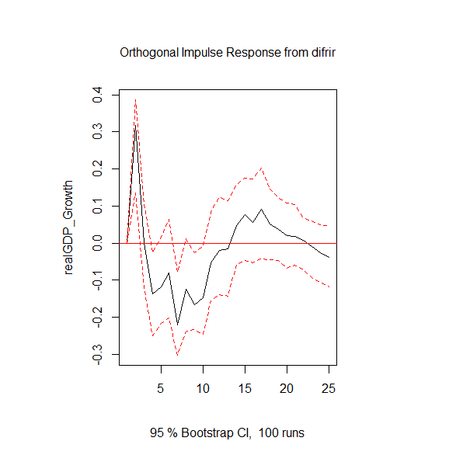

A 1% shock to the real interest rate leads to an unexpected short term increase in output reaching its peak at 0.31% that lasts for 3 periods and the output decreases and stays negative between the 4th period and the 13th period and reaches its lowest point at -0.22% after which it is positive again. Towards the end of the impulse response function (last 3 periods) the output goes negative again. Output does not seem to converge back to its pre-shock levels after 24 periods.

2c) In this exercise we change the ordering of the variables putting money supply in the second position. The new ordering is: real GDP, money supply, real interest rate and inflation rate.

Repeating (2a), below is a forecast error variance decomposition of the real GDP with the new ordering:

|  |  |  |  |  |
| --- | --- | --- | --- | --- |
| **Real GDP Variance Decomposition (New Order)** | | | | |
|  | **Real GDP** | **Real Money Supply** | **Real Interest Rate** | **Inflation** |
| 1 | 1.0000000 | 0.0000000 | 0.0000000 | 0.0000000 |
| 2 | 0.8117088 | 0.03527719 | 0.1429812 | 0.010032863 |
| 3 | 0.8064485 | 0.05423278 | 0.1297782 | 0.009540489 |
| 4 | 0.7517562 | 0.08872561 | 0.1322267 | 0.027291529 |
| 5 | 0.720753 | 0.09420292 | 0.1348324 | 0.050211739 |
| 6 | 0.6810735 | 0.09843529 | 0.1313723 | 0.089118867 |
| 7 | 0.6377721 | 0.10162597 | 0.155527 | 0.105074909 |
| 8 | 0.6040744 | 0.10293763 | 0.1569206 | 0.136067422 |
| 9 | 0.5749392 | 0.09860968 | 0.1686653 | 0.157785852 |
| 10 | 0.5674291 | 0.09659362 | 0.1809261 | 0.155051177 |
| 11 | 0.5569905 | 0.09623072 | 0.1791903 | 0.167588491 |
| 12 | 0.5524368 | 0.09618077 | 0.177604 | 0.173778439 |
| 13 | 0.543518 | 0.09447311 | 0.1743091 | 0.187699736 |
| 14 | 0.5355498 | 0.09550586 | 0.1731268 | 0.195817519 |
| 15 | 0.5284553 | 0.09808389 | 0.1736714 | 0.199789437 |
| 16 | 0.526857 | 0.10044431 | 0.173557 | 0.1991417 |
| 17 | 0.5203593 | 0.10474988 | 0.1750872 | 0.199803647 |
| 18 | 0.5196844 | 0.10583438 | 0.1746623 | 0.19981898 |
| 19 | 0.5170103 | 0.10792769 | 0.1742439 | 0.200818151 |
| 20 | 0.5154832 | 0.11007305 | 0.1735576 | 0.200886166 |
| 21 | 0.5147644 | 0.11070407 | 0.1733646 | 0.201166882 |
| 22 | 0.5143226 | 0.11124461 | 0.172923 | 0.20150976 |
| 23 | 0.5129288 | 0.1114783 | 0.1725673 | 0.203025634 |
| 24 | 0.5103322 | 0.11100254 | 0.1720684 | 0.206596871 |

The table of forecast error variance decomposition of Real GDP above is similar to the exercise 2a). After 24 periods 51% of the variation in GDP is caused by GDP itself, 11% is caused by the money supply, 17% is caused by the real interest rate and 20% is caused by inflation. It would seem that the effects to real GDP are invariant to the ordering of the variables.

Finally, we plot a 24-period orthogonalized impulse response function from real interest to output using the new order:

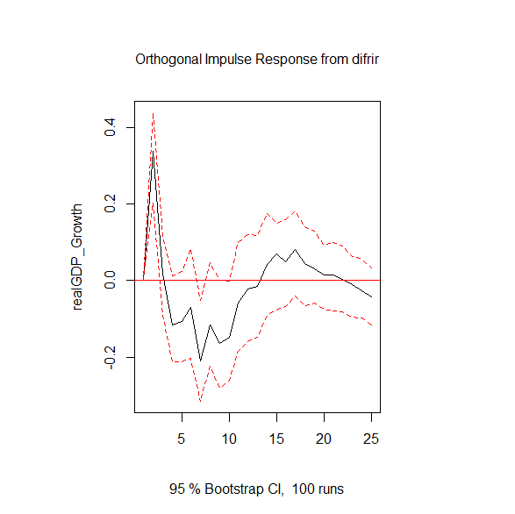

The impulse response of output to a 1% shock to the interest rate in the new ordering has the same shape as the original ordering. That is the output rises initially for the first 3 periods reaching its peak in the 2nd period at 0.33% and then it is negative after the 3rd period and reaches its lowest point in the 7th period at -0.22%. The series suggest that output does not return back to its pre-shock levels. The impulse response supports the conclusion made by the FEVD in the ordering. That is, the effects of money supply to real GDP are invariant to the ordering.

**Structural VAR**

3a) In this exercise I use the original order of the variables: I order the variables as real GDP, real interest rate, real money supply and inflation. Zt below is the (4×1) vector of variables.

The identification of the model above is done by restricting the A and B matrix in the model:

$AZ_{t}= A_{1}^{*}Z_{t-1}+...+ A_{q}^{*}Z_{t-q}+Bε_{t}$

Where Ai* is a (4×4) matrix of coefficients where i = 1…q. Where q=12. Bεt are regression residuals and εt is a (4×1) vector of structural innovations. The A matrix shows the instantaneous relationships between the reduced form residuals and according to Lutkpohl (2009) the B matrix is to identify the structural innovations εt from the regression residuals. In the AB model above the relationship between the regression residuals and the structural innovations is given as Aet = Bεt. (Nwoye, 2012). However, for this question we use an A model which means that the B-matrix is the identity matrix. Therefore we only have to worry about the restriction of the A model. The identification scheme is shown in the matrix below:

1 0 0 0 erealGDP  εreaalGDP

* 1 0 0 ereal interest rate = εreal interest rate

* * 1 0 emoney supply εmoney supply

* * * 1 einflation εinflation

According to Lutkpohl (2009) the A matrix has to have at least *n(n-1)/2* off-diagonal restrictions. The restriction satisfies that condition and the matrix is just identified with six restrictions. In addition, the A matrix satisfies the condition that the money supply does not affect the realGDP contemporaneously only the price level (* in the matrix means the value is freely estimated).

The 24-period impulse response function of money to output is as follows:

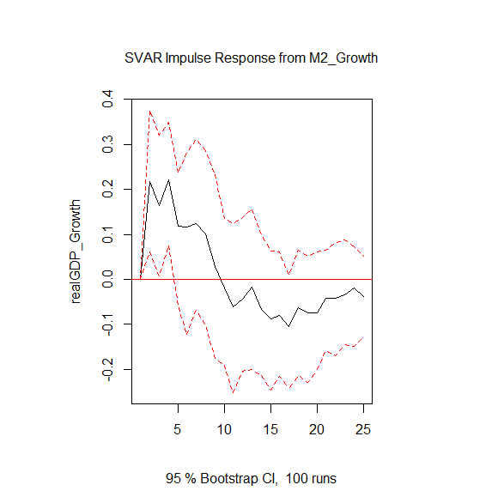

The impulse response function above shows that a 1% shock to the money supply leads to an increase in output it reaches its peak in the 4th period at 0.22% and gradually declines. After the 9th period the output goes negative and stays below its pre-shock level from period 4 to period 24.

3b) Below is the 24-period impulse response function for money to inflation

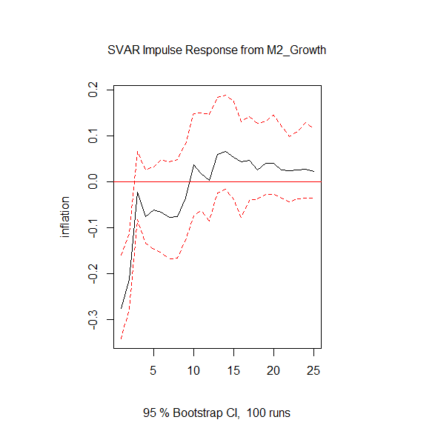

The impulse response function shows that a 1% shock to the money supply leads to an instantaneous drop in inflation to -0.28%. Inflation gradually increases afterwards and becomes positive from period 10. It reaches its peak in period 14 at 0.07% and gradually declines. At the end of 24 periods the inflation is at 0.02% above its pre-shock levels.

3c) In this exercise I make the same identifying assumption to both the money supply and the interest rate. That is, I make the extra identification to the A matrix that the real interest rate does not affect the realGDP in the current period, only the price level. The new identification scheme is as follows:

1 0 0 0 erealGDP  εreaalGDP

* 1 0 0 ereal interest rate = εreal interest rate

* 0 1 0 emoney supply εmoney supply

* * * 1 einflation εinflation

Now I have 7 off-diagonal restrictions.

Below is the 24-period impulse response from money to output with the new A matrix above:

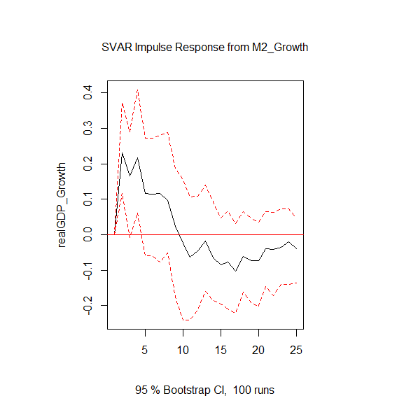

The impulse response function above is the same as in (3a) without the overidentifying restriction.

Below is the impulse response function for money to inflation with the new A matrix above:

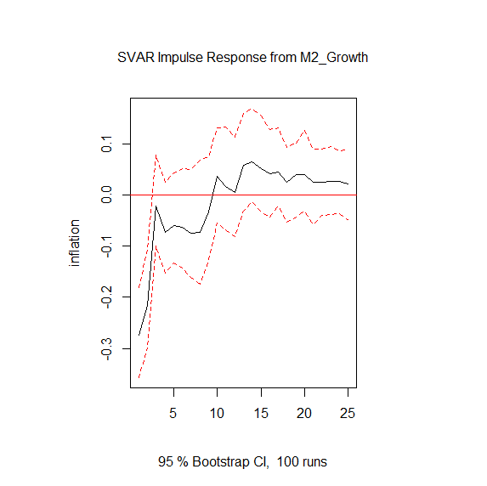

The impulse response function above is the same as the impulse response in (3c). I also tried other changes to the A matrix and the ordering of the variables to fit the restrictions given in the assignment and got similar impulse response functions. This means that the results of the impulse responses seem to be robust to small changes to the model.

Bibliography

Enders W. *Applied Econometric Time Series*. *3rd Edition.* John Wiley and Sons, 2010

Lütkepohl, H. (2005) New Introduction to Multiple Time Series Analysis. Berlin: Springer

Nwoye, A (2012). Macroeconomic Effects of Unconventional Monetary *Policy in the UK: A SVAR Approach*. University of Warwick. Unpublished.